A Scientometric Analysis of DBLP

HAIDER ALI



A DISSERTATION SUBMITTED AS A PARTIAL FULFILLMENT OF THE REQUIREMENTS FOR THE DEGREE OF BACHELOURS IN COMPUTER SCIENCE

DEPARTMENT OF COMPUTER SCIENCES
COMSATS INSTITUTE OF INFORMATION TECHNOLOGY,
WAH CANTT – PAKISTAN

SESSION 2013-2017

A Scientometric Analysis of DBLP

Undertaken By:

HAIDER ALI
Reg. No. CIIT/fA13-bscs-054/Wah

Supervised By:

DR. HIKMAT ULLAH KHAN

A DISSERTATION SUBMITTED AS A PARTIAL FULFILLMENT OF THE REQUIREMENTS FOR THE DEGREE OF BACHELOURS IN COMPUTER SCIENCE

DEPARTMENT OF COMPUTER SCIENCES
COMSATS INSTITUTE OF INFORMATION TECHNOLOGY,
WAH CANTT – PAKISTAN

SESSION 2013-2017

FINAL APPROVAL

Certified that we have read this project report submitted by Mr. Haider Ali and it is, in our judgment, of sufficient standard to warrant its acceptance by COMSATS Institute of Information Technology, Wah Cantt, for the Bachelor degree in Computer Science.

Committee:

1. | External Examiner | ____________________________
 |  | ( | )

2. Supervisor ____________________________

Dr. Hikmat Ullah

4. Head of Department ____________________________

Dr. Ehsan Munir

Acknowledgements

We are grateful to the ALLAH Almighty who provides all the resources of every kind to us, so that we make their proper use for the benefit of mankind. May He keep providing us with all resources, and guidance to keep helping the humanity.

We would like to thank our parents who kept backing us up all the times both financially and morally. We are thankful to them for their prayers.

We would also like to thank Dr. Hikmat Ullah Khan for his guidance and encouraging us to work hard. His critical comments on this work have certainly made me think of new ideas and techniques in the fields of software development.

PROJECT BRIEF

PROJECT NAME A SCIENTOMETRIC ANALYSIS OF
DBLP

ORGANIZATION NAME COMSATS INSTITUTE OF INFORMATION TECHNOLOGY, WAH CAMPUS

OBJECTIVE AUTOMATION OF COORDINATION SYSTEM

UNDERTAKEN BY HAIDER ALI

SUPERVISED BY DR. HIKMAT ULLAH KHAN

ASSISTANT PROFESSOR

DEPARTMENT OF COMPUTER SCIENCE

COMSATS INSTITUTE OF INFORMATION TECHNOLOGY, WAH CAMPUS

STARTED ON SEPTEMBER 2016

COMPLETED ON MAY 2017

COMPUTER USED DELL INSPIRON 5520

SOURCE LANGUAGE C#

OPERATING SYSTEM MICROSOFT WINDOWS 10

TOOLS USED VISUAL STUDIO 2015

Abstract

DBLP (Digital Bibliography and Library Project) is the site which holds the record of all publications, authors of computer science. But it contains dataset and it does not recommend any article or author.
So, for this purpose, I have developed a Windows Application, that can show the statistics like growth of articles, authors per year since beginning and it can also recommend journals, authors and articles on the base of their statistics factors. I used C#, MS SQL Server and LINQ.
This application will store DBLP dataset in SQL Server and will perform analysis using SQL queries and it will show the final visual results in tables and charts through which user will get to know about the statistics and recommendations. This tool can be also helpful for other researchers, through which they can carry out further research by applying different algorithms on resulted data.
My aim is to provide the recommendation for Masters Students to find out which article they should read to carry out their research work. Also Analytics is big field a lot of work has to be done for further analytics. Other researchers can carry out further research using my tool. They can get data prepared, analytics values and reports using my tool.

Table of Contents
1 Introduction 2
1.1 A Scientometric Analysis of DBLP 3
1.1.1 Data Preparation 4
1.1.2 Data Analysis 4
1.1.3 Report Generation 4
1.1.4 Application Interface 4
2 Analysis 5
2.1 Research on Existing Application 5
2.1.1 DBLP File Management System 5
2.1.2 IMDB (The Internet Movie Database) 5
2.1.3 Google Analytics 5
2.1.4 Twitter Analytics 6
2.1.5 The Collection of Computer Science Bibliography 6
3 Design: 7
3.1 Use case Diagrams 7
3.1.1 Use Case Parsing 7
3.1.2 Use Case Database 8
3.1.3 Use Case Report 8
3.2 Activity Diagram 9
3.2.1 Activity Diagram for Parse 10
3.2.2 Activity Diagram Database 10
3.2.3 Activity Diagram Report 11
3.3 Sequence Diagram 11
3.3.1 Sequence Diagram Parsing Data 12
3.3.2 Sequence Diagram for Database 12
3.3.3 Sequence Diagram for Reporting 13
3.4 Class Diagrams 13
3.4.1 Class Diagram for DBLP Main Form 14
3.4.2 Class Diagram of DBLP 14
3.4.3 Class For Data Parsing 16
3.4.4 Class Diagram For Database 17
3.4.5 Class Diagram for Data Analysis 18
3.5 GUI & Results 18
3.5.1 Parse 18
3.5.2 Database 19
3.6 Report & Result 20
3.6.1 Summary 20
3.6.2 Article Citation Growth 22
3.6.3 Author Growth 23
3.6.4 Journal Efficiency Index 24
3.6.5 Relative Activity Index 25
3.6.6 Co-Authorship Index 26
3.6.7 Top Journal Impact Factors 27
3.6.8 Journal Impact Factor Year-wise 28
3.6.9 Top Authors 29
3.6.10 Top Articles 30
4 Implementation 2
4.1 Tools 32
4.1.1 Microsoft Visual Studio – C#.NET community edition 2015 32
4.1.2 MS SQL SERVER 2014 Service Pack 1 Edition 32
4.1.3 XML Library 33
4.1.4 XML LINQ Library 33
4.1.5 SQL CLIENT LIBRARY 33
4.1.6 File Library C# 33
4.2 Key Components 33
4.2.1 Visual Studio 33
4.2.2 SQL SERVER 34
4.2.3 XML Class 34
4.2.4 LINQ Class 34
4.2.5 IO Class 34
4.2.6 SQL Client Class 34
4.2.7 Charts Class 34
5 Experiment and Results 34
5.1 Dataset 34
5.2 Experiment 34
5.3 Results 34
6 Testing 2
6.1 Introduction 2
6.2 Unit Testing 2
7 Conclusion and Future Work 36
7.1 Open Sourcing this project code on GITHUB 36
7.2 Purpose the application to DBLP organization 36
7.3 Using NEO4j Instead of SQL 36
List of Figures
Figure 1 Use Case Diagram 7
Figure 2 Use Case Diagram Database 8
Figure 3 Use Case Diagram Report 9
Figure 4 Activity Diagram Parse 10
Figure 5 Activity Diagram Database 11
Figure 6 Activity Diagram Report 11
Figure 7 Sequence Diagram Parsing Data 12
Figure 8 Sequence Diagram for Database 13
Figure 9 Sequence Diagram for Reporting 14
Figure 10 Class Diagram for DBLP Main Form 15
Figure 11 Class Diagram of DBLP 16
Figure 12 Class For Data Parsing 17
Figure 13 Class Diagram For Database 18
Figure 14 Class Diagram for Data Analysis 19
Figure 15 GUI 20
Figure 16 GUI-Database 21
Figure 17 SUMMARY 22
Figure 18 Article Citation Growth 23
Figure 19 Author Growth 24
Figure 20 Journal Efficiency Index 25
Figure 21 Relative Activity Index 26
Figure 22 Co-Authorship Activity Index 27
Figure 23 Top Journal Impact Factors 27
Figure 24 Journal Impact Factor Year-wise 28
Figure 25 Top Authors 29
Figure 26 Top Articles 30

Chapter 1
Introduction

Introduction

Digital Bibliography and Library Project (DBLP) is a computer science bibliography website. It contains all of its data in its big sized xml file. The scope of this project is that analysis is done on various social website like Twitter, Facebook and YouTube and they have tools for it. The purpose of this project is to provide analysis on website which are academic. The product will analyze DBLP dataset and will generate reports like other tools perform on other sites. This will help researchers to find highly preferred publications and how much these publications are growing, so Researchers can find good publications and will do more research on them.
DBLP is computer science bibliography website. It contains all records in a big size xml file. In this project, we will retrieve data from the data set of DBLP using MS SQL server. And then we will analyze it by statistical techniques using C# dot NET. The statistics will be all about growth of publications, authors etc. The system will show various factors which will recommend articles, journals according to their different factors like Impact Factor, Efficiency Factor etc.


A Scientometric Analysis of DBLP

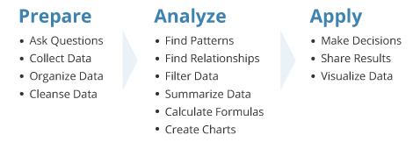
The functions of this product are that it will extract data from a big sized (Xtensible Markup Language) xml file, then it will prepare data from it, and in the main functionality of this product will be DATA ANALYSES. The product will perform ANALYSIS on the data and will generate reports on prepared data.
DBLP Dataset XML Schema:

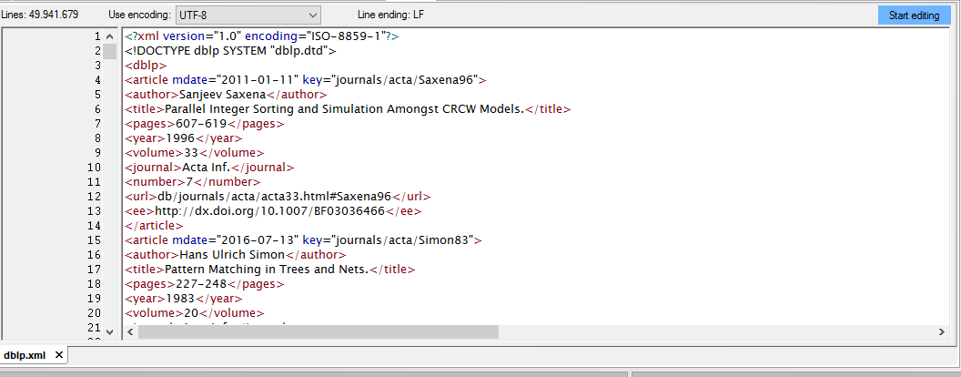

The users of this product will be researchers and data analysists. The will be able to perform analysis kind of stuff.

User Objectives:
The application will provide analysis at the click of button. The user objectives for products are following:
- to prepare data using SQL SERVER out of DBLP xml dataset
- to prepare data which can be queried
- to find out the growth of publications and citation
- to find out average number of publications per year
- to find out growth in the number of authors since 1993.
- to find out publications-wise( journals, workshop and monograph) distribution of publication
- to verify publication efficiency
- to verify activity index
- to verify co-author ship index
- to document domain-wise distribution of publication and citation to find out highly cited publication
- to find out highly preferred journals and document quality of research output

Data Preparation
The system will prepare its data by extracting DBLP.xml file which is 1.8 GB in size. The extracted data will be inserted in SQL SERVER.

Data Analysis
The data in the database will be analyzed using statistical functions which will be taken from C# library. Then it will create models using C# chart controls and zed graphs.

Report Generation
The system will provide reports on analysis. The reports will be generated according to analysis. The reports will be generated easily and efficiently.

Application Interface
The interface will provide tabular views according to type of analysis. The interface will consist of graphs and graphs will be able to plot the lines and figures according to analysis.

Chapter 2
Analysis

Analysis

This chapter will include all the analysis part of our system.

Research on Existing Application
I started the project by doing some research on existing applications. Google Analytics, IMDB, Twitter Analytics and others are providing these types of applications but none of them is for Computer Science Bibliography. DBLP have the own management system which give some statistics report. Their System claims a unique key id for each record which is not unique because they manage all it on java programming using xml file as a dataset. And also their system doesn’t provide the scientometric analysis which can help the user to find the recommended article. My application is totally free of cast and all services are available for free. There are other apps also, but they are for specific services only. Below are details of the apps available.

DBLP File Management System
DBLP System claims a unique key id for each record which is not unique because they manage all it on java programming using xml file as dataset. Plus their dataset also contains redundant data. Which have to be cleaned before it gets inserted in Database. And also their system doesn’t provide the scientometric analysis which can help the user to find the recommended article.

IMDB (The Internet Movie Database)
IMBD is an online database which holds all records of celebrities, movies, directors and everything related to movie. Also it provides a recommendation using its rating function. People rate movies on site, so other people can get recommendation about the movie.

Google Analytics
Google Analytics lets you measure your advertising ROI (return over investment) as well as track you flash, video and social network sites and applications. Also it can give you a report about the traffic and other factors in your network.

Twitter Analytics
Twitter Analytics measure and boost your impact on Twitter. It also measures engagement which can be helpful to find out on how to make your tweet successful. It tracks the information about your followers like (locations, interests, demographics) through which user can find out which kind of tweets his/her followers want to se

The Collection of Computer Science Bibliography
It is a website which is just like DBLP. They provide all the information about each record. They provide some basic statistics. They don’t provide their data source as well as they claim to have 2.3 GBs of data about collections. Also you can query any record using author, title or year queries on their website to find out the record.

Chapter 3
Design

Design:

This chapter will cover the definition of use case diagrams and sequence diagrams, their purposes and the use case and sequence diagrams created for this project.

Use case Diagrams
To model a system the most important aspect is to capture the dynamic behaviour. To clarify a bit in details, dynamic behaviour means the behaviour of the system when it is running or operating.

Use Case Parsing

- First, user have to select xml file.
- User then have to select output path of text file.
- User start Parsing by clicking on parse.
- User can also subscribe to community alerts service.

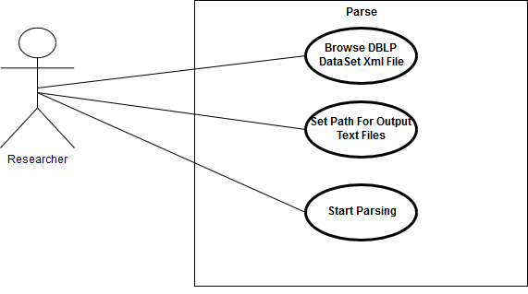
Figure 1 Use Case Diagram

Use Case Database
- User can create tables for data storage.
- User can insert data in tables.
- User can delete data from the tables.
- User can see the data inside the table.
- User can search the data using any attribute.
- User can drop the tables.

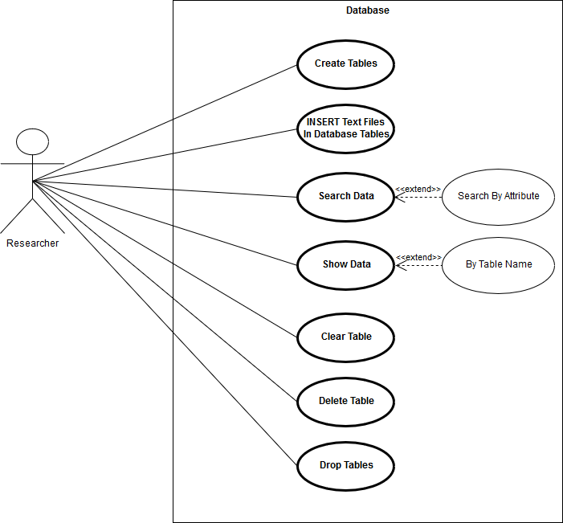
Figure 2 Use Case Diagram Database

Use Case Report
- User can see the results of analysis.
- User can see Article/Citation Growth table and graphs.
- User can see author growth table and graph.
- User can see Journal Efficiency Factor table and graph.
- User can see Journal Impact Factor table and graph.
- User can see top ten Authors and Articles.
- User can see co-authorship index table and graph.

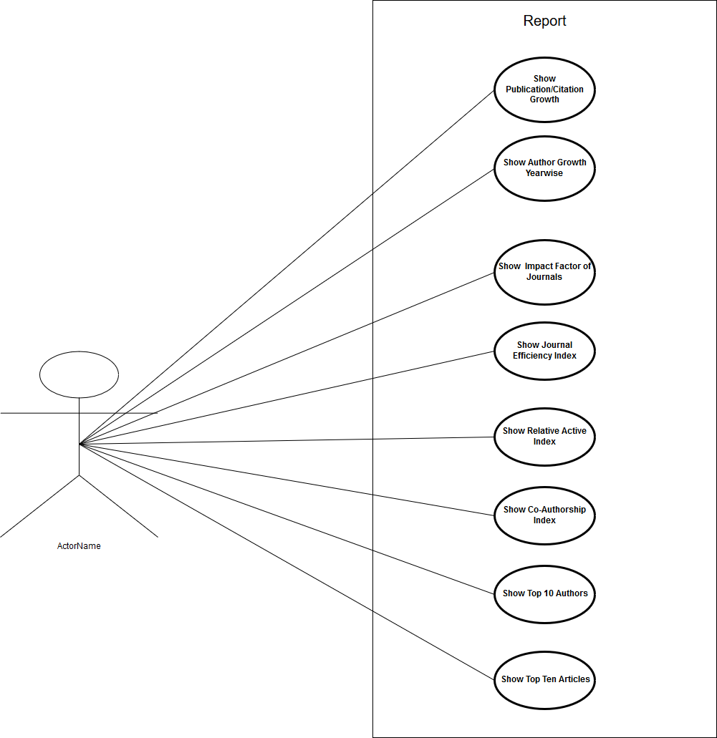
Figure 3 Use Case Diagram Report

Activity Diagram
Activity diagram is basically a flowchart to represent the flow from one activity to another activity. The activity can be described as an operation of the system.
The control flow is drawn from one operation to another. This flow can be sequential, branched, or concurrent. Activity diagrams deal with all type of flow control by using different elements such as fork, join et cetera.

Activity Diagram for Parse

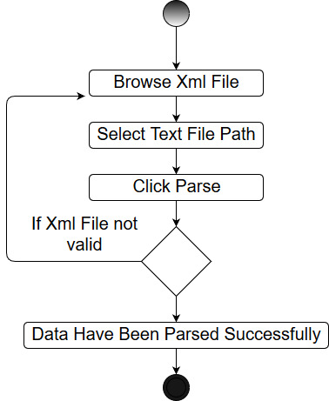
Figure 4 Activity Diagram Parse

Activity Diagram Database

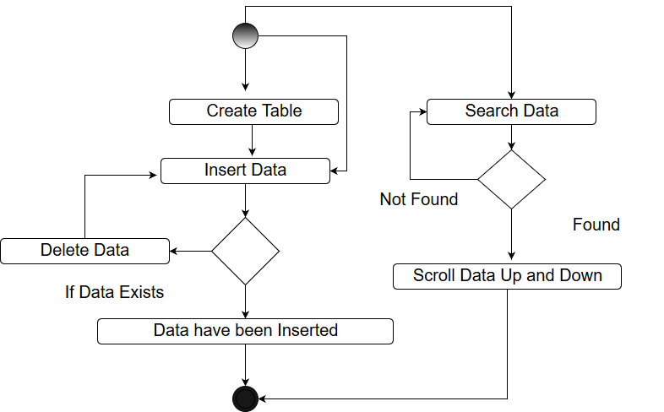
Figure 5 Activity Diagram Database

Activity Diagram Report

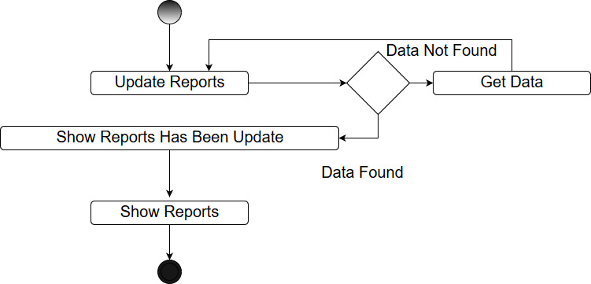
Figure 6 Activity Diagram Report

Sequence Diagram
A sequence diagram is an interaction diagram that shows how objects operate with one another and in what order. It is a construct of a message sequence chart.
A sequence diagram shows object interactions arranged in time sequence. It depicts the objects and classes involved in the scenario and the sequence of messages exchanged between the objects needed to carry out the functionality of the scenario. Sequence diagrams are typically associated with use case realizations in the Logical View of the system under development. Sequence diagrams are sometimes called event diagrams or event scenarios.
A sequence diagram shows, as parallel vertical lines (lifelines), different processes or objects that live simultaneously, and, as horizontal arrows, the messages exchanged between them, in the order in which they occur. This allows the specification of simple runtime scenarios in a graphical manner.

Sequence Diagram Parsing Data
This is the sequence diagram for Parsing Activity. This diagram explains the working of parsing activity.

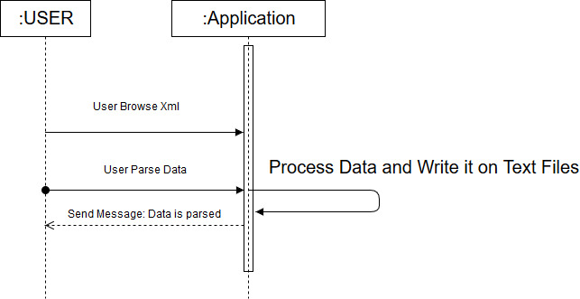
Figure 7 Sequence Diagram Parsing Data

Sequence Diagram for Database
This is the sequence diagram for Database. How user will create, insert and search on Database.
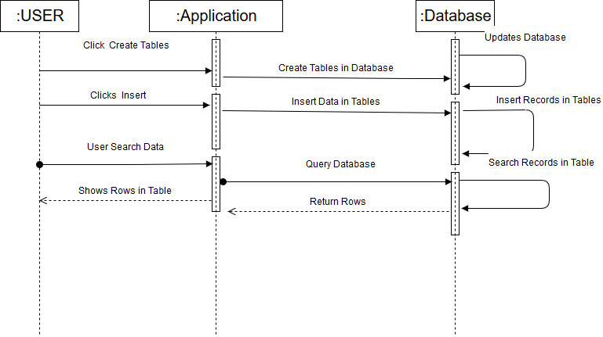
Figure 8 Sequence Diagram for Database

Sequence Diagram for Reporting
This is the Sequence diagram for reporting, that how user will get reports using application and retrieve results from database in application

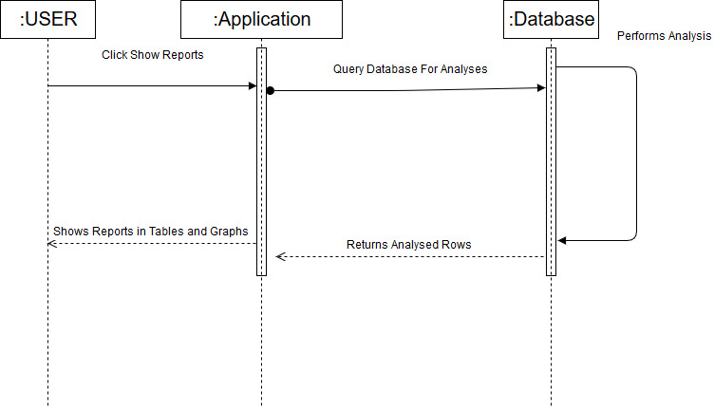
Figure 9 Sequence Diagram for Reporting

Class Diagrams
The class diagram is a static diagram. It represents the static view of an application. Class diagram is not only used for visualizing, describing and documenting different aspects of a system but also for constructing executable code of the software application.
The class diagram describes the attributes and operations of a class and also the constraints imposed on the system. The class diagrams are widely used in the modelling of object oriented systems because they are the only UML diagrams which can be mapped directly with object oriented languages.
The class diagram shows a collection of classes, interfaces, associations, collaborations and constraints. It is also known as a structural diagram.
The purpose of the class diagram is to model the static view of an application. The class diagrams are the only diagrams which can be directly mapped with object oriented languages and thus widely used at the time of construction.
The UML diagrams like activity diagram, sequence diagram can only give the sequence flow of the application but class diagram is a bit different. So it is the most popular UML diagram in the coder community.
So the purpose of the class diagram can be summarized as:
- Analysis and design of the static view of an application.
- Describe responsibilities of a system.
- Base for component and deployment diagrams.
- Forward and reverse engineering.
Now, we discuss about the class diagrams generated for this project.

Class Diagram for DBLP Main Form

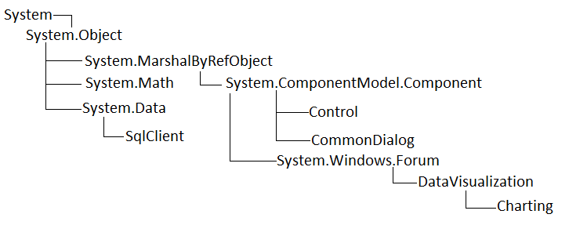
Figure 10 3.4.1 Class Diagram for DBLP Main Form

Class Diagram of DBLP

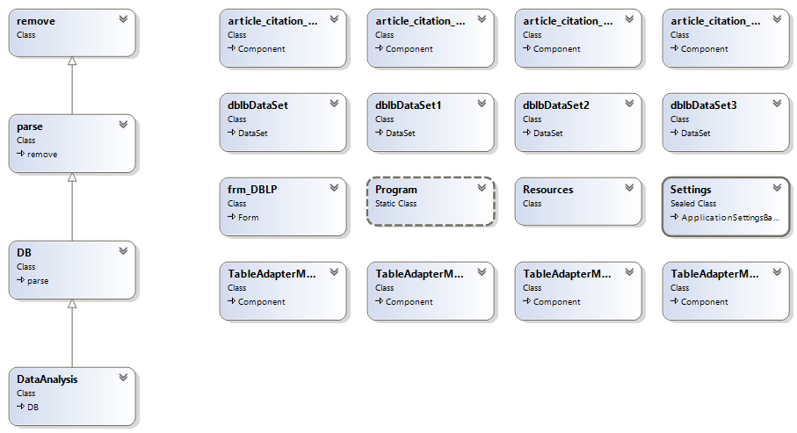
Figure 11 Class Diagram of DBLP

Class For Data Parsing
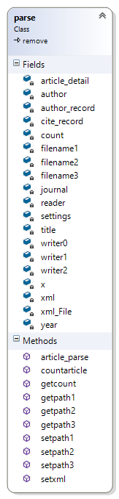
Figure 12 Class For Data Parsing

Class Diagram For Database

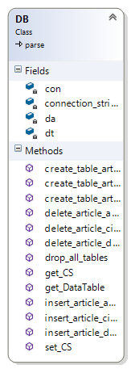
Figure 13 Class Diagram For Database

Class Diagram for Data Analysis
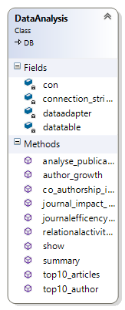
Figure 14 Class Diagram for Data Analysis

GUI & Results
In this section we will discuss the User interface of our application. It has 1 main form, which has 9 sub tabs. All the interface is described below.

Parse
It has two buttons one is for browsing xml dataset file and other one is for parsing.
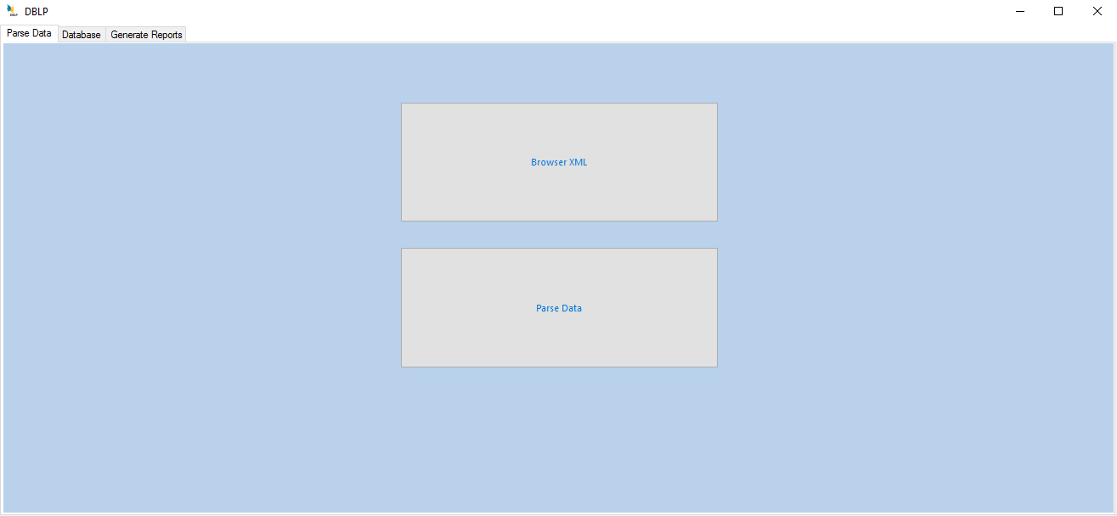
Figure 15 GUI

Database
This tab provides are functionalities, using these we can create tables, delete records, insert record and search any particular record.
It consist of one table which display records. Also it contains two text boxes for setting server and database names.

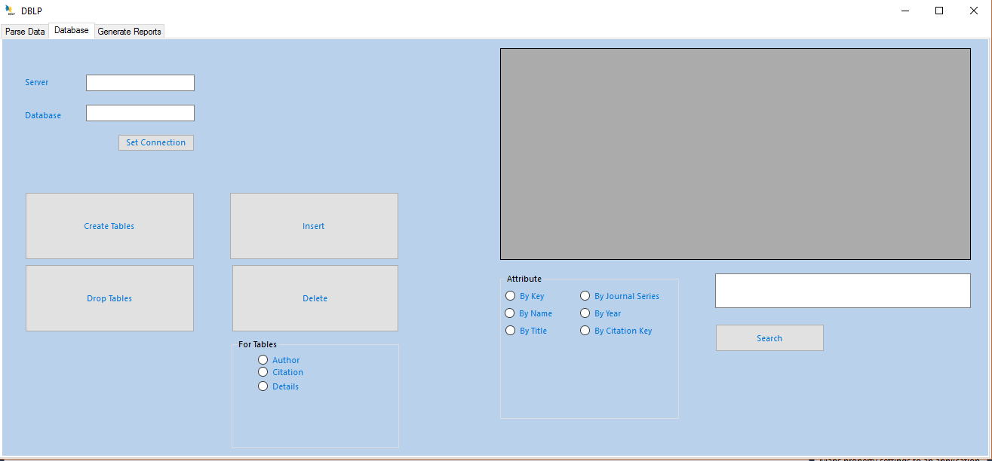
Figure 16 GUI-Database

3.6 Report & Result
These are 9 tabs. Each tab contains its own result in tables and charts.

3.6.1 Summary
This page has one table which contains the count of all authors, article and citations.
Also it has the information of next tab pages and short briefing of what kind of analysis these pages contains.

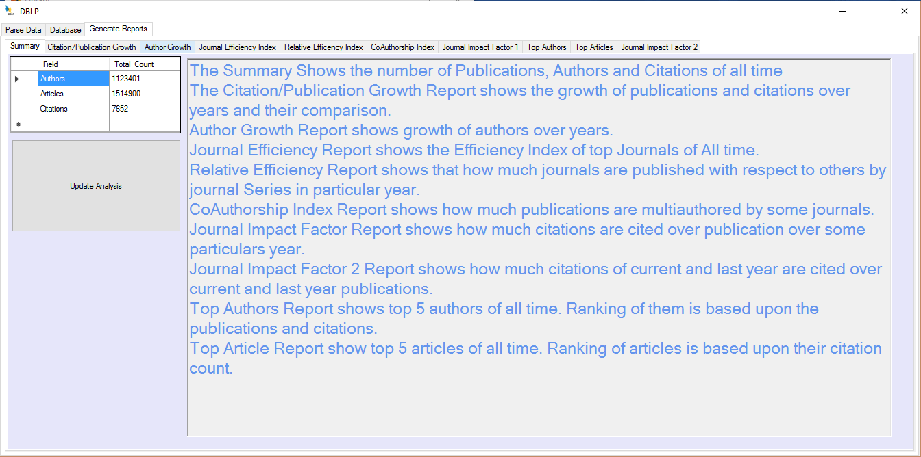
Figure 17 SUMMARY

3.6.2 Article Citation Growth
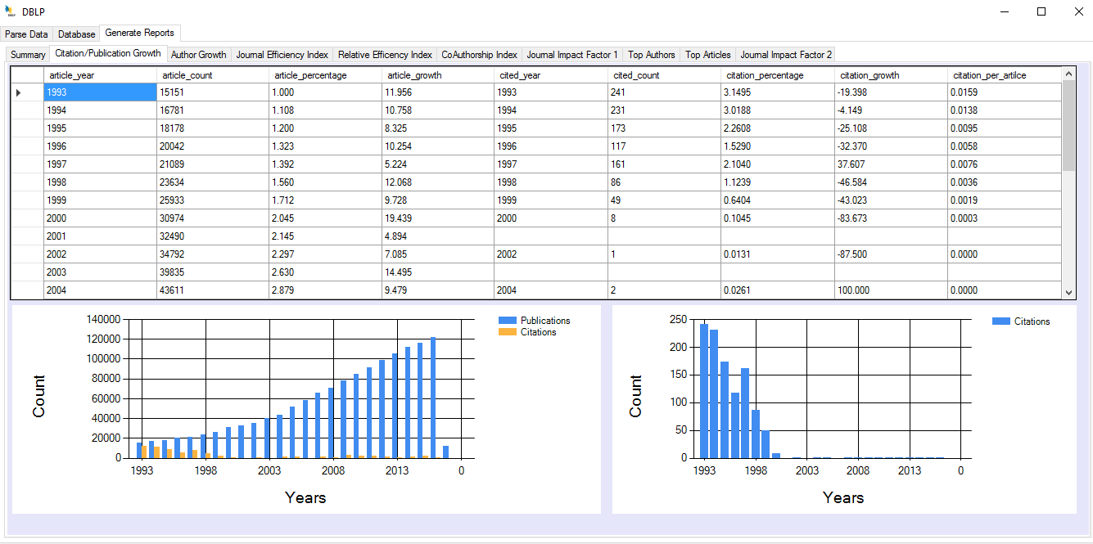
Figure 18 Article Citation Growth

3.6.3 Author Growth
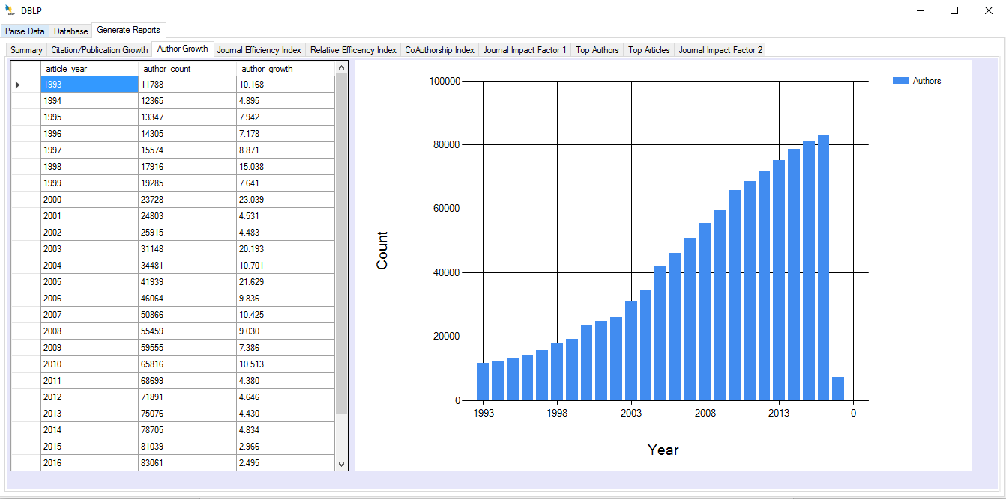
Figure 19 Author Growth

3.6.4 Journal Efficiency Index
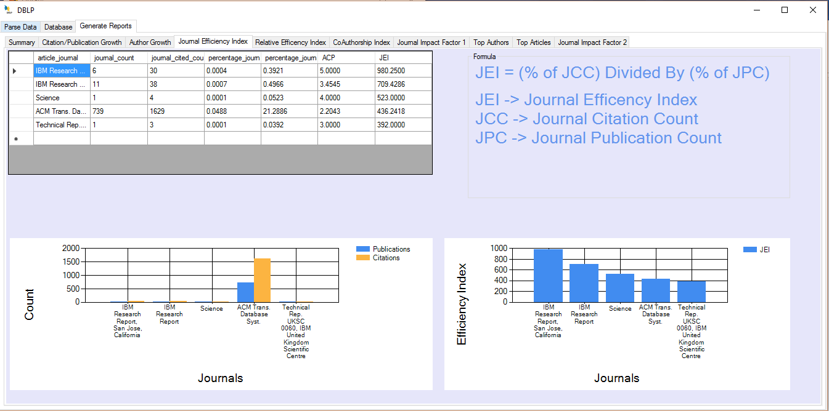
Figure 20 Journal Efficiency Index

3.6.5 Relative Activity Index
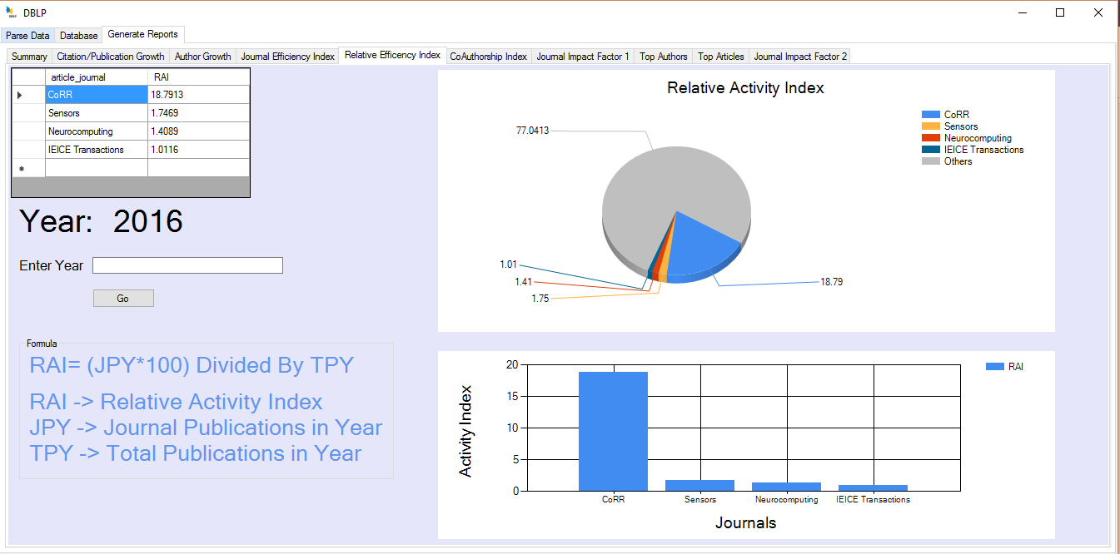
Figure 21 Relative Activity Index

3.6.6 Co-Authorship Index
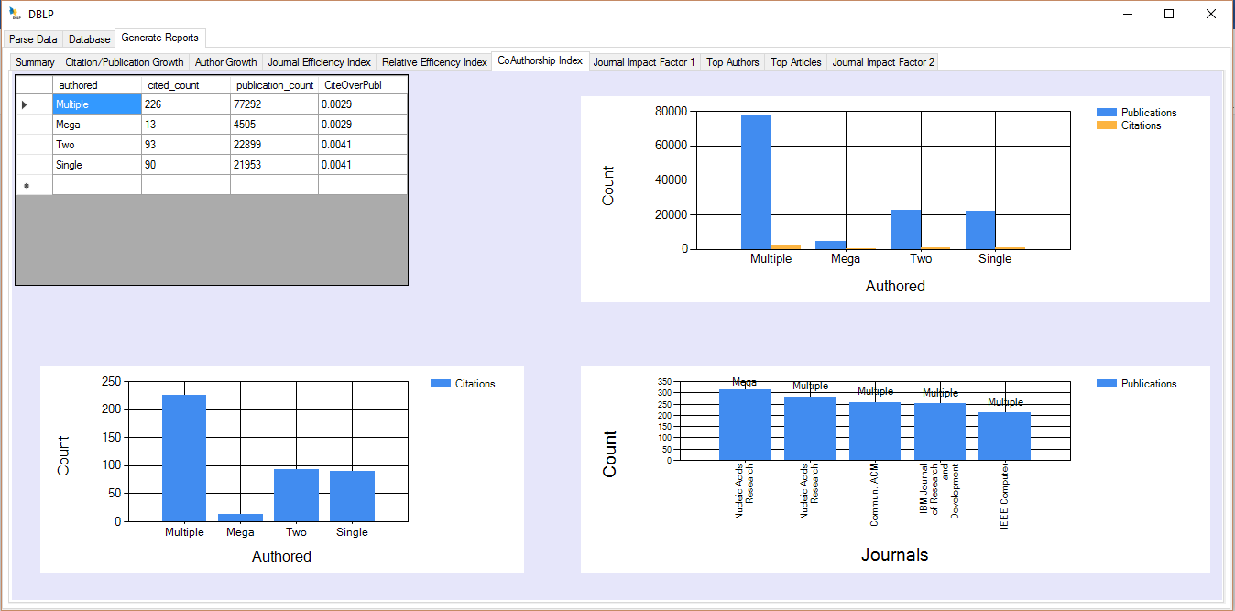
Figure 22 Co-Authorship Activity Index

3.6.7 Top Journal Impact Factors
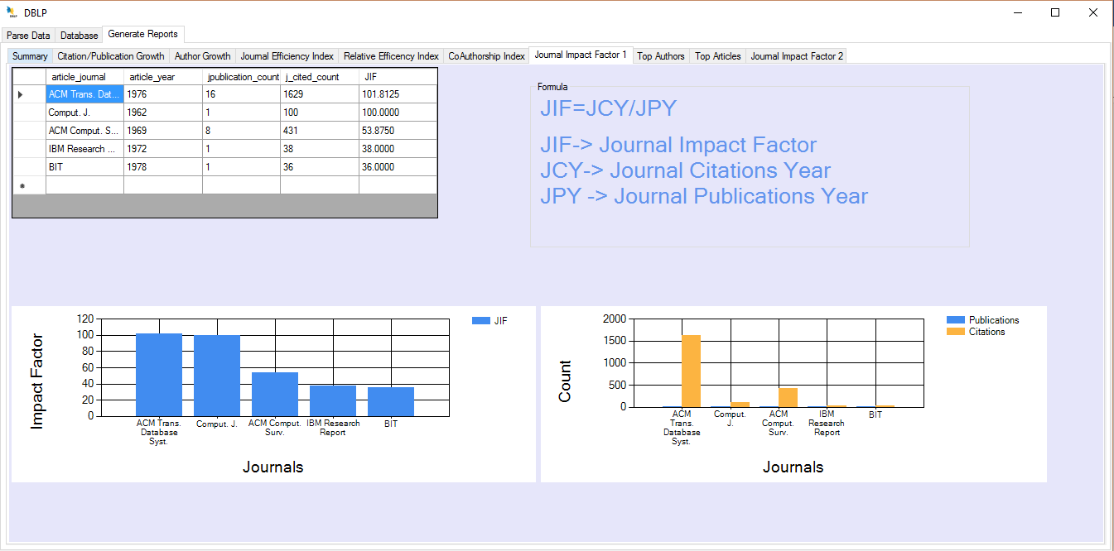
Figure 23 Top Journal Impact Factors

3.6.8 Journal Impact Factor Year-wise
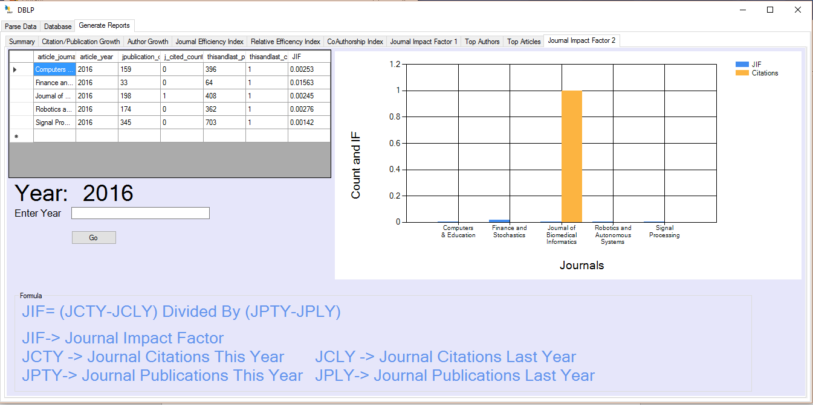
Figure 24 Journal Impact Factor Year-wise

3.6.9 Top Authors

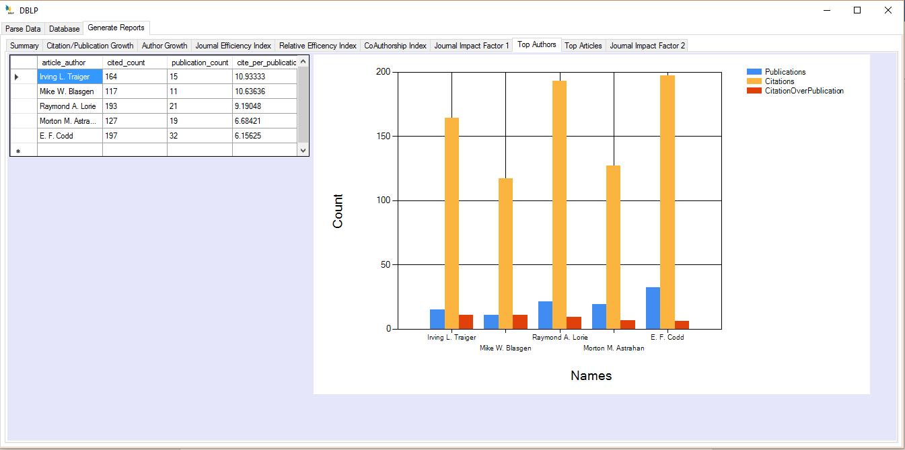
Figure 25 Top Authors

3.6.10 Top Articles
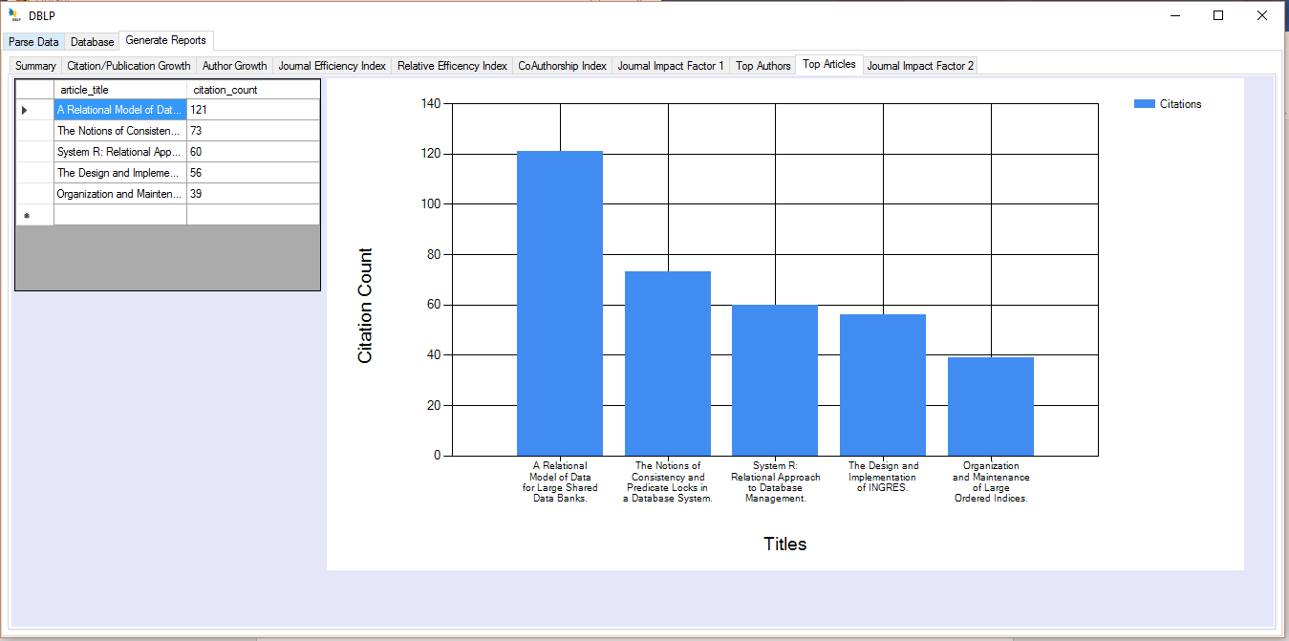
Figure 26 Top Articles

Chapter 4
Implementation

Implementation

The software implementation analyst ensures that deployments of new applications or upgrades are planned and carried out correctly. They act as a bridge between the software developer and the IT infrastructure team that handles installation and maintenance, says Carlo Carbetta, vice president of operations development at CIO Partners, an executive search firm. They determine whether the applications interoperate with existing systems and plan for customization or integration work. This person may be involved in testing, creating documentation and dealing with end users.[6]
[6] http://searchcrm.techtarget.com/definition/implementation
We have implemented the suggested design using the following stages.

Tools

Microsoft Visual Studio – C#.NET community edition 2015
Microsoft Visual Studio is an integrated development environment (IDE) from Microsoft. It is used to develop computer programs for Microsoft Windows, as well as web sites, web apps, web services and mobile apps. Visual Studio uses Microsoft software development platforms such as Windows API, Windows Forms, Windows Presentation Foundation, Windows Store and Microsoft Silverlight. It can produce both native code and managed code.
Visual Studio includes a code editor supporting IntelliSense (the code completion component) as well as code refactoring. The integrated debugger works both as a source-level debugger and a machine-level debugger. Other built-in tools include a code profiler, forms designer for building GUI applications, web designer, class designer, and database schema designer. It accepts plug-ins that enhance the functionality at almost every level—including adding support for source control systems (like Subversion) and adding new toolsets like editors and visual designers for domain-specific languages or toolsets for other aspects of the software development lifecycle (like the Team Foundation Server client: Team Explorer).
Visual Studio supports 36 different programming languages and allows the code editor and debugger to support (to varying degrees) nearly any programming language, provided a language-specific service exists. Built-in languages include C,[6] C++ and C++/CLI (via Visual C++), VB.NET (via Visual Basic .NET), C# (via Visual C#), F# (as of Visual Studio 2010[7]) and TypeScript (as of Visual Studio 2013 Update 2). Support for other languages such as Python,[8] Ruby, Node.js, and M among others is available via language services installed separately. It also supports XML/XSLT, HTML/XHTML, JavaScript and CSS. Java (and J#) were supported in the past.

MS SQL SERVER 2014 Service Pack 1 Edition
MS SQL Server is a relational database management system (RDBMS) developed by Microsoft. This product is built for the basic function of storing retrieving data as required by other applications. It can be run either on the same computer or on another across a network.
- It is also an ORDBMS.
- It is platform dependent.
- It is both GUI and command based software.
- It supports SQL (SEQUEL) language which is an IBM product, non-procedural, common database and case insensitive language.

Usage of SQL Server
- To create databases.
- To maintain databases.
- To analyze the data through SQL Server Analysis Services (SSAS).
- To generate reports through SQL Server Reporting Services (SSRS).
- To carry out ETL operations through SQL Server Integration Services (SSIS).

XML Library
Represents an XML document. You can use this class to load, validate, edit, add, and position XML in a document.

XML LINQ Library
Contains the classes for LINQ to XML. LINQ to XML is an in-memory XML programming interface that enables you to modify XML documents efficiently and easily.

SQL CLIENT LIBRARY
The System.Data.SqlClient namespace is the.NET Framework Data Provider for SQL Server. It provides methods which can perform all kind of queries for SQL Server.

File Library C#
Provides static methods for the creation, copying, deletion, moving, and opening of a single file, and aids in the creation of File Stream objects.

Key Components

Visual Studio
I used its dot net framework for application design and backend programming in C#.

SQL SERVER
I used it for structuring and storing data and for fast querying which can perform fast analysis. Also all analytical queries were implemented in SQL. SQL Joins (Full Joins, Right Joins, Left Joins and Natural Joins), Scalar Functions (Convert (decimal, field)) and Aggregate Functions (count (field), sum (field)) functions were used for traversal, conversion and calculation of data respectively.

XML Class
I used this library to access and extract out XML nodes in XML dataset. I used XML Reader method which is very fast in traversing xml node. It doesn’t load data in DOM. It just read node by node in straight manner.

LINQ Class
As we know that XML class many methods. Some load full document, some methods just read node by node in straight manner. So, this LINQ class method XNode takes nodes and extracts out further data from reader. I used it for structuring data like which kind of sub nodes should be extracted out from xml reader node.

IO Class
This class is used for managing data inside a text file. I used for writing formatted data from LINQ nodes to file. The data from text file is inserted in SQL Server Database tables.

SQL Client Class
This class is used for querying SQL server. Queries like inserting, deleting, creating and other aggregate queries which was performed for analysis are done using this class-methods.

Charts Class
This class contains the method and properties for the Chart win form control. I used it for data visualization and reporting. Histograms and pie-charts are used in project using this class.

Chapter 5
Experiments and Results

Experiment and Results

Dataset
The proposed application is tested on 2 datasets of DBLP. DBLP updates its file every month. The dataset from October 2016 and February 2017 was tested. In these six months data was expanded by 300 MB from 1.8 GB to 2.1 GB. Dataset is contained by xml file. DTD (Data Type Definition) file has to be set before parsing. DTD is set using XML editor. Dataset consist of bibliographical details of computer science.

Experiment
I queried the data from Database like searched by author name. Also I applied scientrometric analytic queries on data which brings some top authors, articles, journals.

Results

The records were 100 percent matched with DBLP dataset. As, you can search any record on DBLP site. The results were the same. But my results are had some extended values which were calculated values. I compared computed values with manual computed values. They were also correct.

Chapter 6
Testing

Testing

Introduction
This test plan will outline and define the approach that will be taken to perform formal system tests on the application. The test is performed to verify the system function.
We have focused on thorough testing through-out the design and implementation phase. While testing the modules and application, we noticed the application was running without any problem.

Unit Testing
Each module in the application was tested while being developed to confirm its adherence to the related requirements. This testing was performed on individual modules and components.

Chapter 7
Conclusion and Future Work

Conclusion and Future Work
In this project, I have developed an analytical tool which will be used to perform scientometric analysis on DBLP dataset and it will recommend the top authors, journals et cetera, using dot net app and SQL server and C# language and its predefined libraries, which successfully achieved the objective of the project. There could be several improvements possible. Some of the ideas for future development is mentioned below:

Open Sourcing this project code on GITHUB
Further algorithms like machine learning and other algorithms could be perform to find out more complex factors. Also other students, researchers can use the parser in my application to extract out data from DBLP anytime they like. As well, the parsing tool is very fast and efficient, as it can extract 500 MB of data from XML in less than a minute depends on other factors. Also it removes redundant strings from nodes. Other people can improve it more. And they can perform other kind of analysis on parsed data. Also the scientometric values provide values which can be used for further research and analysis.

Purpose the application to DBLP organization
As, my tool could perform scientometric analysis and it removes duplication of IDs. It used SQL server instead of XML file and java. DBLP can use my analytics to show it on their website for users who will find out more recommended articles for their research work.

Using NEO4j Instead of SQL
When I started this project, for me SQL technology was best for data storage and querying data. As I progressed in my project I found out some better technologies for data storage and querying data like Neo4j. Neo4J is graph based database management system. Which is much faster than SQL server and it provide querying just like SQL server plus it provides many other relational queries for analyses. Which make Neo4j very much better than SQL Server. So, in future I will convert my data tool to NEO4j from SQL.

